[Paper’s title, Helvetica 14, bold]

Abstract: this template exemplifies the style to be used in the papers sent to the Sophia. The abstract should be a summary of the topic covered, the approach taken and the conclusions and should not exceed 10 lines.
Keywords: template-paper, style, citation rules. [Italic 11, adjusted alignment, max. of 5 keywords]

Title: …
Abstract: This ….
Keywords: ….

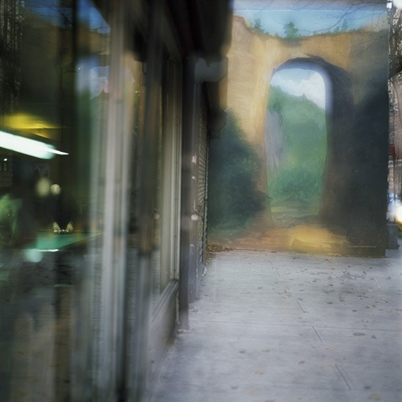

Virgílio Ferreira, Untitled from series “Uncanny Places”, 2007; 100 x 100 cm; Inkjet print, fine Hahnemühle art paper, edition 5/5; Solomon R. Guggenheim Museum, New York
Introduction [or other title. For all titles: Helvetica 12, bold]
Sophia hereby requests, in order to be able to easily and expeditiously edit the contents sent by the authors, adopting the graphic design and style of the collection, that the authors follow the formatting of the paper as this document indicates, being the most easy to do so by taking advantage of this same file and replacing its contents.

[All text of the article, except the beginning, citations’ blocks, captions and bibliography: Helvetica 12, alignment adjusted, paragraph without indentation, without footnotes]

1. Title [this is the title of the first chapter of the paper; if there are sub-chapters, they must be numbered, eg 1.1 or 1.1.1]
The page is formatted with margins of 3 cm on top and on the left, 2 cm on the right and bottom. The normal spacing is 1.5 except in the area of the abstracts, at the beginning, and in the area of bibliographical references. All paragraphs have no spacing before and after. No headers or footers are used.

For the peer review process to be double-blind, delete from this file any reference to the author and do not make self-references.

2. Citations
Is considered as citations’ rules the ones that follows this system “author, date,” or “Harvard,” without the use of footnotes.

3. Figure or Tables
In the text of the paper, only one figure (an image, drawing, or photograph) is allowed, and if it exists, it will be located at the beginning of the paper, as exemplified here.
The image file must be identified and numbered (FIGURE1) and the caption file of that image must be identified and numbered according to the image description (CAPTION1).

The caption text of the image should attempt to respond, when possible, to the following fields: author, figure Title, project title, location, date, dimensions, technology, print type, contributions, other credits, as indicated in the example in this article .
In the ’Table’ category are the tables that, instead, are captioned above (see table below).

Table with list of issues to elaborate territorial subjects I
1. Container and contents
- a descriptor of spatial organization
- a narrative device about the disposition of things in space
- an array (where you create and produce something, where you define something more or less explicit and known that regulates and organizes rules and codes)
- descriptive code of patterns, shapes and limits
- an explanation and production device for meaning
2. Space location system
- GPS
- far, near; extension; Area of influence
- variation according to attributes, taxonomies and lists
3. A regulatory framework
- vital territory
- ecosystems and territoriality
- political and administrative geography, sovereignty
- territory and power; (The "province", the "region", the "city" ...)

The author of the paper is responsible for authorizing the reproduction of all the contents of his work.

4. About the references
The chapter 'References' presents the mentioned sources, and only those. Increasingly, bibliographic lists tend to include references to non-paper materials such as videos, DVDs, CDs, or websites (pages, databases, * .pdf, online monographs or periodicals, photos, films) . The “References” chapter is unique and is not divided into subchapters.

Conclusion
The Conclusion should present a synthesis capable of summarizing the essentials and communicating as clearly as possible the body and argument of the paper, presenting the most important points of view.

References [This title: Helvetica 12, bold; All following list: Helvetica11, left-aligned]

Artiga, L. S. (2007). PAISAJES INVISIBLES/PARAJES IMPOSIBLES. In F. E. d. A. Contemporani (Ed.). Girona.
Augé, M. (1995). Non-places: Introduction to an Antropology of Supermodernity. London: Verso.
Certeau, M. d. (1984). The Practice of Everyday life. Trans. Steven Rendall. Berkeley: University of California Press.
Flam, J. (Ed.). (1973). Entropy Made Visible. Interview with
Alison Sky. Berkley: University of California Press.
Ribas, X. (1998). Barcelona Pictures. Salamanca: Ediciones Universidad de Salamanca.
Ribas, X. (2003). Perfect Distraction. London: Zelda Cheatle Gallery.
Ribas, X. (2005). SANCTUARY. Barcelona: Gustavo Gili.
Ribas, X. (2006a). Del Paisage Reciente. In Fundación ICO / Photo Espana (Ed.), Invisible Structures. Madrid: Fundación ICO.
Ribas, X. (2006b). Invisible Structures. SOURCE(49).

